For immediate release

Limited edition hand-bound book from Māori poet Anahera Gildea

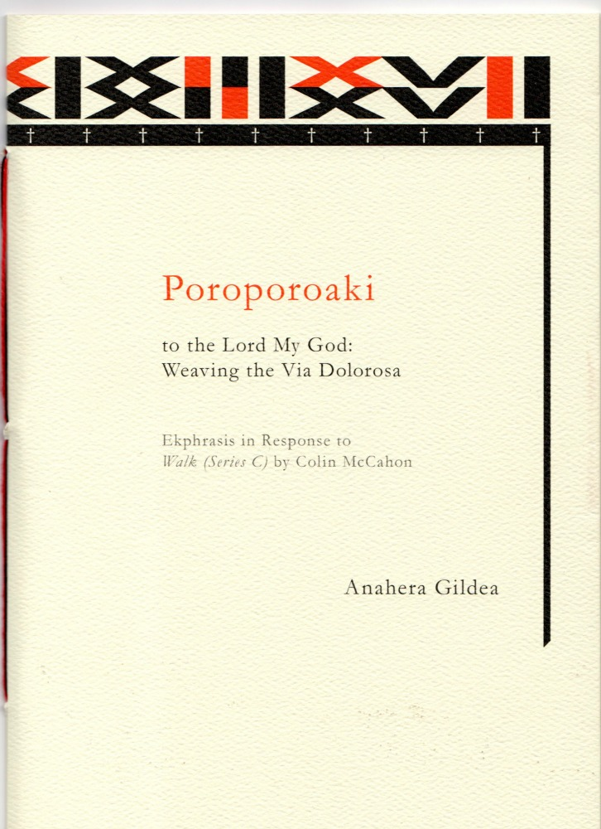

Māori writer Anahera Gildea has just released her poem Poroporoaki to the Lord My God: Weaving the Via Dolorosa: Ekphrasis in Response to Walk (Series C) by Colin McCahon in a hand-bound and hand-numbered limited first edition of just 150 from Seraph Press.
Poroporoaki is, as the subtitle suggests, a response to Colin McCahon’s paintings that are in turn a response to the death of poet James K. Baxter. In this rich poem up-and-coming writer Anahera Gildea takes these threads and weaves them into a vivid Māori cultural context. The result is powerful, emotional and beautiful.
Gildea says: “A poroporoaki is essentially a farewell. To someone known. It is a ritual of goodbye, and Walk Series C struck me as having that same slow, deliberate purpose. It also refers to the Via Dolorosa, the fourteen stations of the cross that Christ walked carrying said cross on his way to his own crucifixion.”
This exquisitely produced hand-bound book is available in a first edition of 150 hand-numbered copies. It is bound with hemp and flax-linen thread, and features a fly-leaf insert of harakeke (New Zealand flax) paper, hand made by Pakohe Papers in Whanganui.
Anahara wrote this poem early during her masters year at Victoria University’s IIML, when the students took a field trip to Te Papa. She was writing a novel for her MA, but a poem felt like the right form to respond to Colin McCahon’s painting. She sent it to JAAM magazine, which in that year (2014) was guest edited by Sue Wootton, who accepted the poem for the ‘Shorelines’ issue.
Gildea comments on her choice of art form: “Poetry is like music. Where there should be a lament, or party music, or a drum roll, that’s a poem. It’s visceral. I’m not taking you on a road trip, we won’t really get to know each other as people, but I will take you for a short ride on my bike cos it feels like flying and that’s worth sharing.”
Helen Rickerby, who runs Seraph Press, came upon Gildea’s work when she was proofreading JAAM, of which she is co-managing editor. “It totally captivated me. I am a big fan of both McCahon and Baxter, and I had recently been reading about this painting and Māori weaving and cloaks as part of my job as an editor at Te Ara – the Encyclopedia of New Zealand. I was so moved by it and amazed at the layers upon layers in what is a relatively short poem. I kept on thinking about the poem and it occurred to me that it would make a perfect book, all by itself.”
The design of the book was a collaborative effort, with Helen designing the inside, and Anahera creating the taniko pattern from Roman numerals, which evokes a cloak on the front and back covers. “We wanted it to be a beautiful object, as well as a beautiful poem,” Helen says.
Poroporoaki is published by Seraph Press, a boutique publishing company run by Wellington poet Helen Rickerby, which is gaining a reputation for publishing beautiful, high-quality poetry books.
Notes
- The author is available for interview – please contact publicist Elizabeth Heritage on 022 652 3981 or books@elizabethheritage.co.nz
- Poroporoaki is available to purchase from http://www.seraphpress.co.nz/poroporoaki.html and from selected NZ bookstores now.
- Media materials, including high-quality images of the book cover and author, are available for download from www.seraphpress.co.nz/media
- ISBN: 978-0-9941345-0-9; Format: Paperback, 210 mm (tall) x 148 mm (wide), 20 pages; RRP: $20; Publication date: April 2016

