For immediate release

New collection of poems celebrates the Big Apple

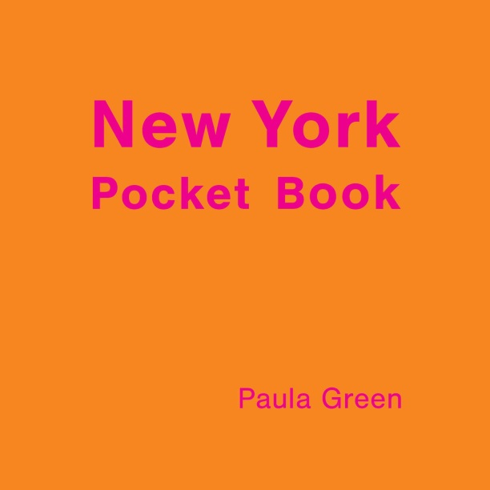
Respected Kiwi poet Paula Green turns her thoughtfulness and linguistic playfulness in a new direction in her latest poetry collection, New York Pocket Book, out this month from Seraph Press. This reflective meander around a new city – the Big Apple – is part travelogue, part essay on the nature of poetry.
New York Pocket Book was inspired by a trip Green took to New York City with her family. Green says: “I had built a NYC in my head that was calibrated from TV shows and fiction, so the real thing busted that into a thousand molecules and then reassembled with smell and taste and infectious noise.”
Our guide for our journey around NYC in New York Pocket Book is the character of Josephine, whose eyes we see everything through, but who remains enigmatic.
Green says: “I liked the idea of a figure that could carry bits of me but that also carried bits of not-me so I could tell the truth and invent to my heart’s delight … It is all about how you experience something for the first time and how that experience hits you quick and smart, slow and deep, in so many different ways.”
The square pocket-sized volume has a striking bright-orange cover featuring pink text. Publisher Helen Rickerby, who designed the book, says “While the book is about New York, it’s also about much more than that – it’s about everything. So I didn’t want a picture of some New York icon on the cover – it would have been too restrictive, and too twee. I had this idea of making it look like a cool little guidebook – a guidebook to New York in poetry.”
As well as being a widely respected poet, Green is a tireless ambassador for poetry in Aotearoa and runs two popular poetry blogs: NZ Poetry Box for children and NZ Poetry Shelf for adults. She says: “Poetry is way of holding onto life. We all do it differently and that is what makes it so wonderful.”
New York Pocket Book is published by Seraph Press, a boutique publishing company run by Wellington poet Helen Rickerby. It is available in bookshops around Aotearoa.
Notes
- The author is available for interview – please contact publicist Elizabeth Heritage on 022 652 3981 or books@elizabethheritage.co.nz
- Some poems from the book are available for republication, please contact publicist.
- New York Pocket Book is available to purchase from http://www.seraphpress.co.nz/new-york-pocket-book.html and from selected NZ bookstores now.
- Media materials, including high-quality images of the book cover and author, are available for download from www.seraphpress.co.nz/media
- ISBN: 978-0-9941345-2-3; Format: Paperback, 148 mm (tall) x 148 mm (wide), 80 pages; RRP: $25; Publication Date: June 2016
Paula Green is a poet, reviewer, children’s author, NZ Book Award judge and anthologist. She has published six previous collections of poetry, plus three collections for children, most recently The Letterbox Cat & Other Poems (Scholastic, 2014). She edited the anthologies A Treasury of NZ Poems for Children (Random House, 2014) and Dear Heart: 150 New Zealand Love Poems (Random House, 2012), and co-authored 99 Ways into New Zealand Poetry (Random House, 2010) with Harry Ricketts. She is currently working on a book about New Zealand women’s poetry.

