For immediate release

New illustrated poem from celebrated NZ poet Bernadette Hall
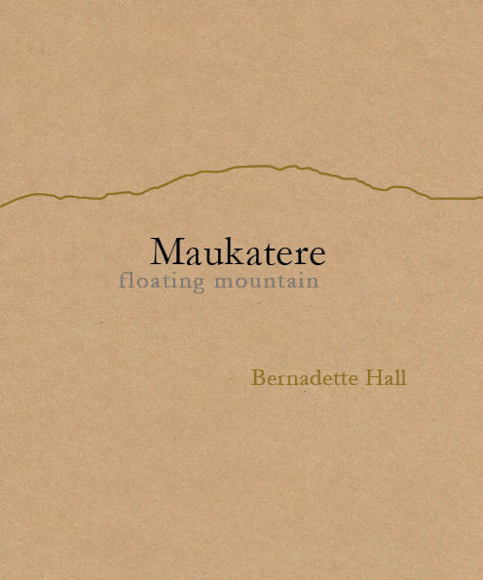

Maukatere: Floating Mountain by Bernadette Hall is a single long poem sequence that explores and celebrates life below Maukatere (Mt Grey) in the Hurunui, Canterbury. The more experimental style is an exciting development for Hall, one of New Zealand’s most eminent poets and winner of the 2015 Prime Minister’s Award for Literary Achievement for poetry.
In 2003 Hall moved from Christchurch to Amberley Beach in the Hurunui, and the poem is partly inspired by her walks around the area with her trekking group: “The Mountain Goats, average age about 70 but all fantastically fit. And then there’s the different tugs of history. Not so many people use the name ‘Maukatere’ out here. It’s so beautiful. I wanted to hold up the beauty of the name and trek around it.” Maukatere, in the local dialect, literally means ‘floating mountain’, from the way low cloud often gathers around it, leaving the top look as it is floating.
Beautifully produced by Seraph Press, the hand-bound book is printed on luxurious art paper and features 10 exquisite drawings by Rachel O’Neill, who is a poet herself as well as a film-maker and graphic essayist.
Hall, who enjoys working with other artists, invited Rachel O’Neill to collaborate with her after seeing her artwork. “Rachel had completely free rein to go where she would. The way the tangles and webs of her artwork shift the emphases inside the language, these are mysteries and profoundly moving insights for me.”
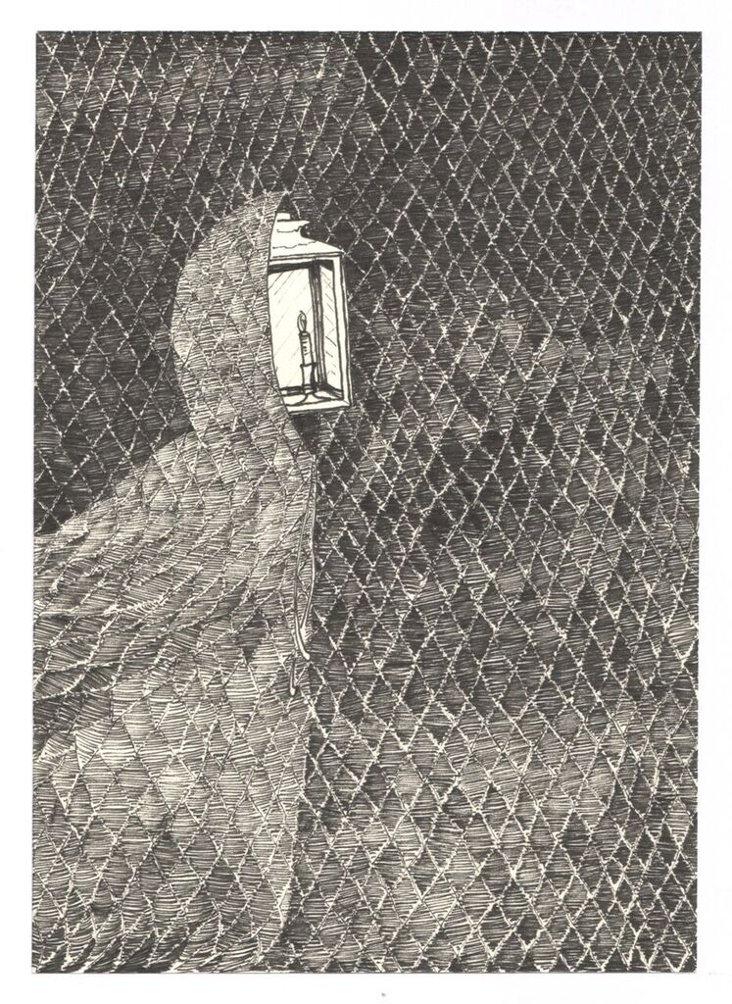
O’Neill says: “The poem seared into me in a very personal way and the lines, Bernadette’s extraordinary lines, were an artist’s dream. So evocative, and full of emotion that could walk the talk of realism and surrealism with equal conviction. A character emerged, the Hooded Lantern, a figure who wears a hoodie and who has a lantern for a face.”
Originally published in a limited hand-numbered first edition of 170, it sold out almost immediately and came in at number 3 in the NZ fiction for adults bestseller lists. A second edition is now available, and is available in bookshops around Aotearoa, or through the Seraph Press website.
Maukatere is published by Seraph Press, a boutique publishing company run by Wellington poet Helen Rickerby, which is gaining a reputation for publishing beautiful, high-quality poetry books.
Notes
- The author is available for interview – please contact publicist Elizabeth Heritage on 022 652 3981 or books@elizabethheritage.co.nz
- Some poems are available for republication, please contact publicist.
- Maukatere is available to purchase from http://www.seraphpress.co.nz/maukatere.html and from selected NZ bookstores now.
- Media materials, including high-quality images of the book cover and author, are available for download from www.seraphpress.co.nz/media
- ISBN: 978-0-9941345-1-6; Format: Paperback, 210 mm (tall) x 177 mm (wide), 32 pages; RRP: $25; Publication Date: May 2016
Bernadette Hall is one of New Zealand's leading poets. She has published 10 previous collections of poetry, including The Merino Princess: Selected Poems (VUP, 2004) and, most recently, Life & Customs (VUP, 2013).
Following a career as a high school teacher, she co-founded the Hagley Writers’ Institute in Christchurch. She now lives with her husband John in a renovated fisherman’s bach at Amberley Beach in the Hurunui, North Canterbury.
Rachel O'Neill is a film-maker, writer and artist based in Te Whanganui-a-Tara, Aotearoa. She seeks out fresh ways to see and understand life and art. She strives to represent the humour, candour and strangeness at the heart of human experience. Her first poetry collection, One Human in Height, was published by Hue & Cry Press in 2013.

