For immediate release

Bilingual collection celebrates Māori women’s poetry and te reo Māori

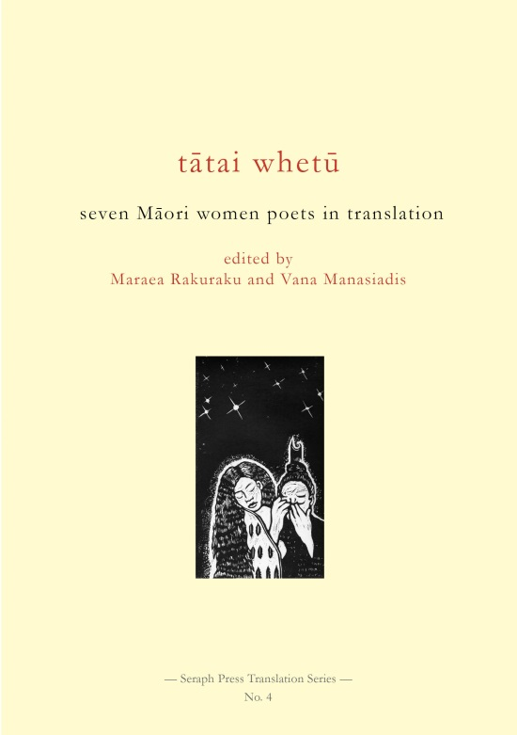
Despite its small size, Tātai Whetū: Seven Māori Women Poets in Translation is a ground-breaking bilingual collection of poetry. Tātai Whetū, which will be launched at Wharewaka o Pōneke during Writers & Readers, features a poem each by seven Māori women writers, originally written in English, and a translation in Māori. The two versions of the poems are presented on facing pages.

The featured poets are Anahera Gildea, Michelle Ngamoki, Tru Paraha, Kiri Piahana-Wong, Maraea Rakuraku, Dayle Takitimu and Alice Te Punga Somerville, who currently live in Te Whanganui-a-Tara (Wellington), Tairāwhiti (Gisborne), Te Moana a Toi (Bay of Plenty), Kirikiriroa (Hamilton) and Tāmaki Makaurau (Auckland).

Their poems were translated by Hēmi Kelly, Te Ataahia Hurihanganui, Herewini Easton, Jamie Cowell, Dayle Takitimu and Vaughan Rapatahana.

Co-editors Maraea Rakuraku and Vana Manasiadis, who are both poets and translators themselves, worked together on both the book and on a poem that serves as an introduction to the collection. They approached poets whose work they admired to ask them to submit a poem for the book. While not all are well-known poets, and only one (Kiri Piahana-Wong) has published a full-length collection to date, they are all poets to watch. They’re active in their poetry communities and have had work published in anthologies and journals.

The title, Tātai Whetū, translates as a constellation of stars; and it’s no coincidence that there are seven poets included, corresponding to the seven stars of Matariki, also known as the Pleiades and the Seven Sisters. Stars are a recurring theme through the book, along with the wider theme of mana wahine.

Tātai Whetū is the fourth book in the Seraph Press Translation Series, which has previously published bilingual collections of poetry from Greek, Italian and French. While the series originally began to introduce poetry from other languages to Aotearoa New Zealand audiences, the series co-editors, Manasiadis and Seraph Press publisher Helen Rickerby, very quickly realised they also wanted to celebrate New Zealand’s own indigenous language.

This gorgeous chapbook is hand-bound with hemp thread and features cover artwork by Miriama Grace-Smith.

Seraph Press is a boutique literary publishing house in Wellington, New Zealand. It was founded in 2004 by Helen Rickerby, and has gained a reputation for publishing high-quality and beautiful books of poetry.
Notes

Launch details:
When: Sunday 11 March, 2 pm
Where: Mākaro room at Te Wharewaka o Pōneke, next to the lagoon on Wellington’s waterfront

Title: Tātai Whetū: Seven Māori Women Poets in Translation
Editors: Maraea Rakuraku and Vana Manasiadis
Authors: Anahera Gildea, Michelle Ngamoki, Tru Paraha, Kiri Piahana-Wong, Maraea Rakuraku, Dayle Takitimu, Alice Te Punga Somerville
Translators: Hēmi Kelly, Te Ataahia Hurihanganui, Herewini Easton, Jamie Cowell, Vaughan Rapatahana
Category: Poetry
ISBN: 978-0-9951082-0-2
Format: Paperback, 210 mm (tall) x 148 mm (wide), 40 pages
RRP: $20
Publication Date: March 2018

- The editors, and some poets and translators, are available for interview – please contact publicist Elizabeth Heritage on 022 652 3981 or books@elizabethheritage.co.nz
- Tātai Whetū: Seven Māori Women Poets in Translation is available to purchase from http://www.seraphpress.co.nz/publications.html and from selected NZ bookstores from 12 March.
- Media materials, including a high-quality image of the book cover, are available for download from www.seraphpress.co.nz/media.

About the poets

Anahera Gildea (Ngāti Raukawa-ki-te-tonga, Ngāi te Rangi, Ngāti Toa Rangatira, Te Āti Awa, Kāi Tahu) has worked extensively as a visual and performing artist, a writer, and a teacher. She has had her poems and short stories published in multiple journals and anthologies, and her first book, Poroporoaki to the Lord My God: Weaving the Via Dolorosa, was published by Seraph Press in 2016. She holds a BA in art theory, graduate diplomas in psychology, teaching, and performing arts, and a master’s degree in creative writing from Victoria University.

Michelle Ngamoki
Tu ake au ki runga i a Hikurangi, te maunga tapu
Peka atu au ki a Whanokao, ara ki a Patangata.
E rere atu au ki te matarae o Pokohinu
Marakerake taku titiro ki a Whakaari, ara ko Te Paepae o Aotea
Ki Tawhitinui, ki Tawhitiroa!
E kore au e ngaro, he kakano i ruia mai i Rangiatea.
Tena ra tatou katoa.
Michelle Ngamoki is an indigenous poet and mama, who uses storytelling, poetry and spoken word as avenues for expressing and exploring indigenous truth and indigenous resistance. She is of Te-Whānau-ā-Apanui and Ngāti Porou descent, and is a fierce advocate for protecting the relationship between indigenous peoples and the eternal knowledge held within Te Ao Turoa, the ancient world.

Tru Paraha (Ngāti Hine, Ngāti Kahu o Torongare) is an independent artist working with choreography, performance, and text. Her extensive collaborative and commissioned projects expand across theatre, poetry, video, visual art, and experimental dance. Recent choreographies KARE; kind artificial real experience (2016) and blackout (2018) were performed at the Kenneth Myers Centre in Auckland as part of an ongoing trilogy of works exploring concepts of darkness. Reviews and performance articles by the artist can be found in Theatrereview and forthcoming publications of DANZ Magazine, Performance Research Journal and the book Undisciplining Dance. Selected poems appear in Blackmail Press, Puna Wai Kōrero and Poetry New Zealand.

Kiri Piahana-Wong (Ngāti Ranginui) also has Chinese and Pākehā (English) ancestry. She is a poet and editor, and is the publisher at Anahera Press. Her poems have appeared in over 40 journals and anthologies, and she has edited issues of JAAM magazine and Flash Frontier. Her first poetry collection, Night Swimming, was released in 2013; a second book, Tidelines, is due out later in 2018. Kiri lives in central Auckland with her partner and baby son.

Maraea Rakuraku creates work that investigates, examines, calls out and celebrates Te Ao Māori and our navigation of 21st century Aotearoa New Zealand. Her thoughtful fierce intellectualism and grounding in her Tūhoe and Ngāti Kahungunu identity is matched only by her heart and commitment to giving voice; all of which is reflected in her poetry, theatre (The Prospect, Tan-Knee, Te Papakāinga) and theatre reviewing (Theatreview, Pantograph Punch). Frustration at representations of wāhine Māori in theatre has led to a PhD with the International Institute of Modern Letters at Victoria University of Wellington, which she starts in 2018. Further frustration led to the founding of Native Agency Aotearoa, created to grow minority and indigenous visibility in the arts.

Dayle Takitimu
Ko Oariki te maunga, Ko Waipapa te awa, Ko Ngati Paeakau/Te Whanau a Tuwahiawa te hapu
Ko Te Whanau a Apanui te iwi.
Ko Puke maire te maunga, Ko Reporua te awa, Ko Ngati Rangi te hapu
Ko Ngati Porou te iwi.
Ko Maungahaumi te maunga, Ko Waipaoa te awa
Ko Te Aitanga a Mahaki te iwi.
Ko Titirangi te maunga, Ko Uawanui-a-Ruamatua te awa
Ko Te Aitanga a Hauiti te iwi.
Ko te Aroha, ko te Whakapono, ko te Tumanako, ko te Rangimarie, tatou tatou e.

Dayle Takitimu is a barrister and solicitor of the High Court, who has practised in Māori, indigenous and environmental law. She had led protests of her tribe, Te-Whānau-ā-Apanui against drilling for deep sea oil in the Raukumara Basin.

Alice Te Punga Somerville (Te Ātiawa, Taranaki) is a scholar, poet and irredentist. She is Associate Professor in the Faculty of Māori and Indigenous Studies at the University of Waikato, where she writes and teaches at the intersections of Indigenous, Pacific, literary and cultural studies. Her first book was Once Were Pacific: Maori connections to Oceania (Minnesota 2012) and she is currently researching Indigenous writers who published their work between 1900 and 1975. She agrees with Thomas King that ‘the truth about stories is that’s all we are’.

About the translators

Jamie Cowell hails from Waikato, Ngāti Porou and Ngāti Pākehā. She was raised in Glen Innes, loves her whānau and is currently a Māori language lecturer at Te Ara Poutama, AUT University. She has teaching experience at various levels of Māori language, culture and protocol, and is a second language learner of te reo Māori. This translation work marks a first for her, and she is humbled and privileged to share her passion for the language through this collaboration with other wāhine Māori, who she commends for speaking their truth through the inspiring and thought-provoking pieces they have shared with us.

Herewini Easton is a descendant of legends, from historic and herstoric narratives embedded in Pare Hauraki-Coromandel Peninsula, Maniapoto-Te Awamutu, Ngāti Rehu-Rotorua and Wērā-Wales.
A product of Māori and English words, concepts, theories, philosophies.
A libra, a tiger and a raven, ‘neath the rowan tree.
From the sage to the page to the stage.
Thus, the words of our lives. Kia ora
Te Ataahia Hurihanganui (Ngāti Tūhourangi, Ngāti Tūwharetoa, Ngāti Tahu, Ngāti Ira, Ngāti Porou), also known by her nickname Taahia, is a passionate multilingual who loves learning about other languages and cultures as well as her own. She wears many professional hats: Māori language teacher, tutor-trainer, translator to name a few, but her favourite role in the world is that of being Māmā to two-year old Mario and ‘puku-baby’ (due in April 2018).

Hēmi Kelly is of Ngāti Maniapoto and Ngāti Tahu-Ngāti Whāoa descent. He is a full-time lecturer in te reo Māori at the Auckland University of Technology and an assistant researcher at Te Ipukarea, the National Māori Language Institute. Alongside the Māori language, Hēmi has a passion for waiata composition, writing, translation and Māori visual and performing arts. Hēmi is a licensed translator and a graduate of Te Panekiretanga o Te Reo, the Institute of Excellence in the Māori language.

Vaughan Rapatahana commutes between Hong Kong SAR, Philippines and Aotearoa New Zealand. He’s widely published across several genre in Māori, English and other languages. He was a semi-finalist in the Proverse Prize for Literature in 2009; highly commended in the 2013 erbacce poetry prize (from 6000+ entrants); won the inaugural Proverse Poetry prize in 2016, the same year as his poetry collection Atonement was nominated for a National Book Award in Philippines. His latest poetry collection is ternion (erbacce-press, Liverpool, England).

Dayle Takitimu, see bio above.

About the editors

Maraea Rakuraku, see bio above.

Vana Manasiadis is a Greek-New Zealand poet and teacher who has been moving between Aotearoa and Greece, and is now living in Tāmaki Makaurau/Auckland. She is the co-editor of the Seraph Press Translation Series, was the editor and translator of Ναυάγια/Καταφύγια: Shipwrecks/Shelters: Six Contemporary Greek Poets (2016), and the author of poetry collection Ithaca Island Bay Leaves: A Mythistorima. Her work with translation considers Forrest Gander's idea that ‘there are political ramifications to crossing [or not crossing] linguistic borders’.

