For immediate release

Debut collection of essays go beyond the personal

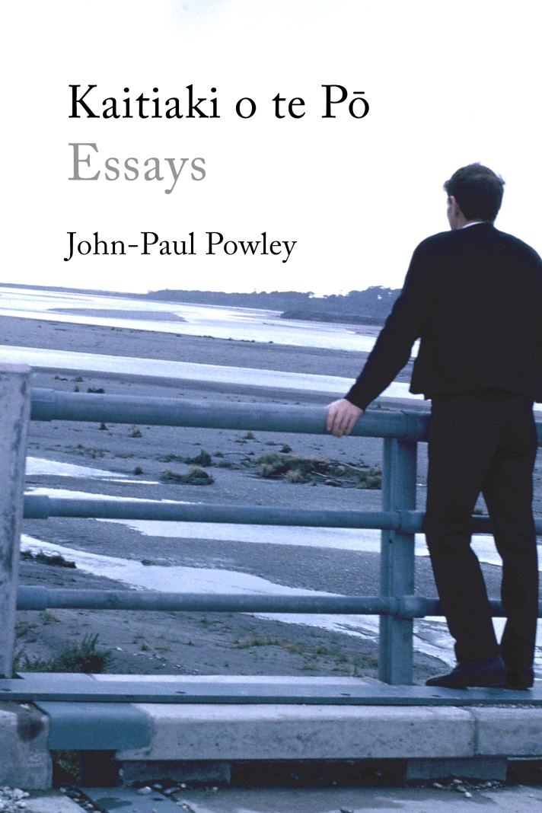
Wellington writer John-Paul Powley, whose debut book Kaitiaki o te Pō: Essays was published at the beginning of December, thought for a long time that his first book would be a novel he wrote almost 25 years ago. “I wasted a lot of time in my life thinking that ‘proper’ writing was writing a novel, not realising that proper writing is actually whatever you enjoy writing about in whatever way. For a person as astonishingly self-absorbed as me it seems ridiculous that I failed to observe that what I most loved to read – non-fiction that was close to fiction, or fiction that was close to non-fiction – would be the thing I would most enjoy to write.”

Creative non-fiction in general, and personal essays in particular, are having a heyday internationally, and have been taking off in New Zealand too. In this book, Powley joins essayists such as US author Rebecca Solnit, whose ‘personal’ essays go far beyond the simply personal but also examine larger issues in our society.

Topics that Powley tackles with intelligence, deep thinking, and often wit, include the untimely death of a friend; a school field trip around India; how the murder of missionary Karl Völkner by a small number of men meant land confiscation for an entire iwi; how our history plays out in our present, especially for Māori; growing up as a sensitive boy in a patriarchal society; his experiences of being a high-school Dean trying help the ‘difficult’ kids; and why young men, such as Keats and grunge rockers, are perhaps not the best people to give you advice on how to live your life after all.

Powley, a Pākehā teacher of history and social studies, found resonance in the idea expressed by Justice Joe Williams at a history teachers’ conference. As he writes in the title essay: “Historians, he said, were ‘kaitiaki o te pō’. This translates to mean the caretakers of the night …. Suddenly I felt honoured to be a teacher of history; honoured and charged with a great responsibility.”

In these essays Powley harnesses the power of stories to tell us about ourselves and where we come from, acting as a caretaker of history and memory. He says “There are three reasons I am drawn to the past: to understand myself; to understand the meaning of life, and to put the present into perspective.”

Kaitiaki o te Pō: Essays marks the first foray into prose non-fiction for boutique publishing company Seraph Press, which has previously been known for publishing beautiful books of high-quality poetry. Poet and publisher Helen Rickerby, who founded Seraph Press in 2004, says “Taking on a book of essays was a little daunting at times, because essays have so many more words than poetry, but I loved these essays so much I had to take on the project. I am really excited and honoured to be bringing John-Paul’s amazing work to a wider audience.”

John-Paul Powley lives in Wellington with his wife and two daughters. He has taught English in Japan, and history and social studies in New Zealand. His essays have been previously published in JAAM, Headlands and The Spinoff.

Notes

Title: Kaitiaki o te Pō: Essays
Author: John-Paul Powley
Category: Essays
ISBN: 978-0-9941345-9-2
Format: 210mm (tall) x 140mm (wide), 166 pages
RRP: $35
Publication Date: December 2018

- John-Paul Powley is available for interview – please contact Seraph Press managing editor Helen Rickerby on 027 738 5997 or contact@seraphpress.co.nz.
- Kaitiaki o te Pō: Essays is available to purchase from https://www.seraphpress.co.nz/kaitiaki.html and from selected NZ bookstores now.
- Media materials, including a high-quality image of the book cover, are available for download from www.seraphpress.co.nz/media.

